***Given the provided data, what are three conclusions that we can draw about crowdfunding campaigns?***

Based on this crowdfunding data, we uncover numerous outcomes for fundraisers such as who uses them, when they are used and of course, how successful they are.

In reference to the chart representing fundraiser time frames via month, whilst you can see successful fundraisers peak during the months of January, June & July, it very well corresponds to the overall quantity of fundraisers for each month. Whilst this data may prove fundraisers are frequently started during these months, there is no indication within the data to suggest one will be successful starting a fundraising campaign during a certain month of year.

In reference to the charts illustrating categories of fundraisers for both parent & sub-categories, there are exceptional outliers (which makes up for well over half fundraisers) under ‘performing arts categories’ such as theatre, music, film & video, as well as plays for the sub-categories. This very well suggests that these fields are dependent on & well supported by fundraising campaigns.

In reference to the same charts displaying data for categories, utilising the filter option allows us to filter out data via country. Doing this we recognise the US is responsible for starting most of these fundraising campaigns. Over 75% in fact.

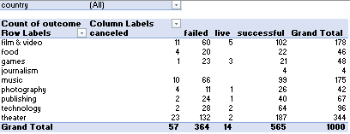

Global Data

US Data

***What are some limitations of this dataset?***

Whilst this dataset gives us information on goals, support, success, time frames & categories. The limitations lie in the fact that each fundraiser has underlying factors such as advertisement & outreach to audience, which both play major parts for a fundraiser to reach its goal. This dataset does not contain any of this information. If included, we would very likely have a validated conclusion on what makes a successful fundraiser.

***What are some other possible tables and/or graphs that we could create, and what additional value would they provide?***

With the information that’s been provided, it would have been worth implementing a table which compared the success of the fundraising campaign to the monetary goals & the timeline for each fundraising campaign. It is certainly possible where some fundraisers have set too high of a goal for their timeline, or even underestimated what they could accomplish within their timeline. Charting this data would benefit in recognising that as a factor.